Hi deepshikha

hi
hellow
jiii

kkkkkk

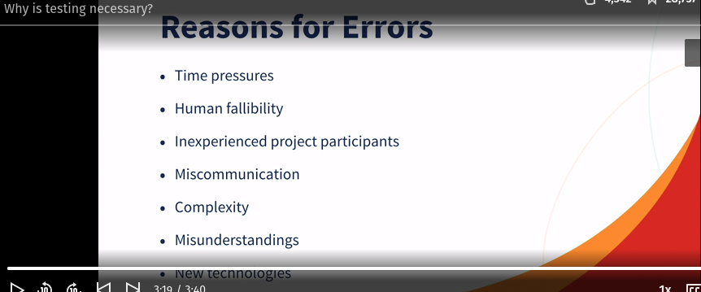

Seven Principle of Testing -
- Testing Shows the presence of defects not their absence
- Exhaustive testing is impossible – Testing everything is not possible
- Early testing save time and money
- Defects cluster together
- Beware the pesticide paradox - New test cases is needed
- Testing is context dependent
- The absence of error is a fallacy

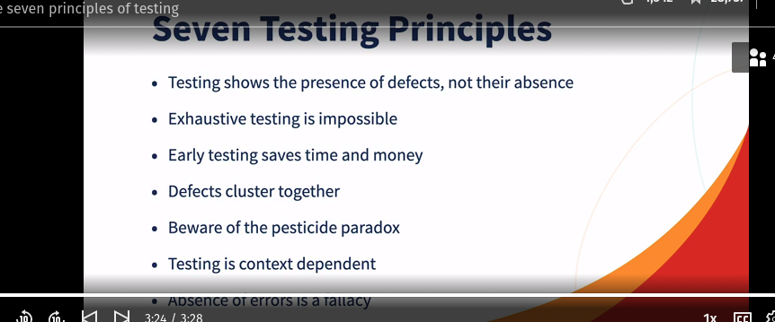

Software test process -

Factors -
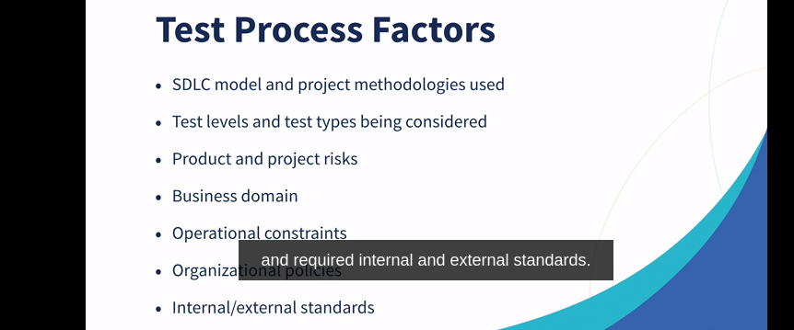
Activities -

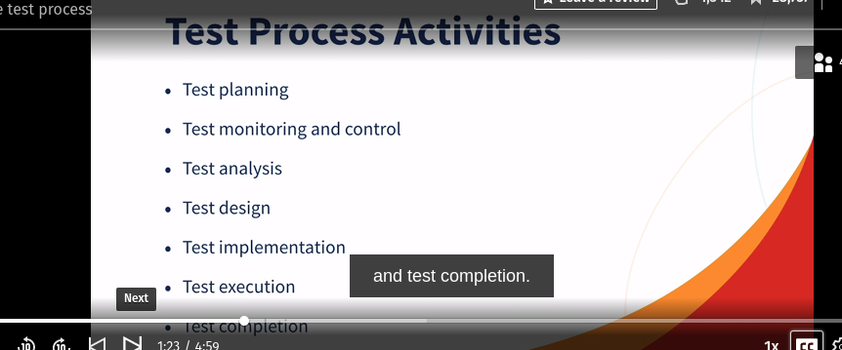
‘
Test Planning – Involves activities that define the objective of testing and the approach for meeting test objectives

Test monitoring and control –
Monitoring - Comparison of actual process against planned progress
Control – Taking actions necessary to meet objective in test plan

Both supported by evaluation of exit criteria (definition of done)

Test Analysis -
System under test is analyzed to identify testable features
determine what to test

Test Design
Test conditions are elaborated into high-level test cases
Defines how to test
Identigy necessary test data
designing test environment
Test Implementation -

Testware is necessary for test execution is created
Defines if you have everything is place to run the tests
Developing and prioritizing test procedures
Creating test suites from test procedure
preparing test data

Test Execution -

Recording the IDs and versions of the test item or test objects, test tools and testware
Executing test either manually or through tools
Comparing actual results from the expected results
Logging the outcome of test execution

Test Completion

Checking whether all defect reports are closed
Creating test summary report
Finalizing and archiving the test environment
Handing over all the testwares to the maintenance team, other project teams or stakeholders who could benefits from its use
Using the information gathered to improve test process maturity

Psychology of testing -

Confirmation bias -

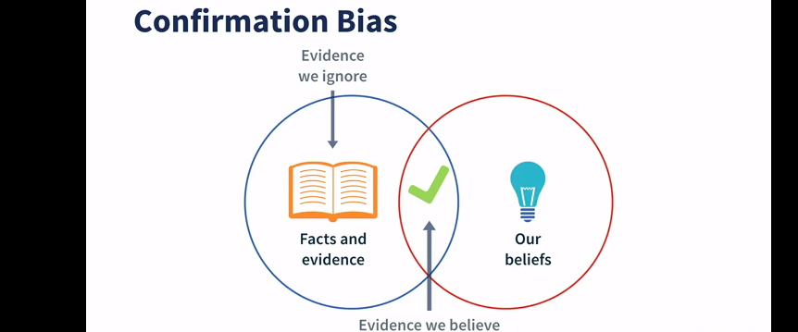

It is difficult for Developers to accept that their code is incorrect

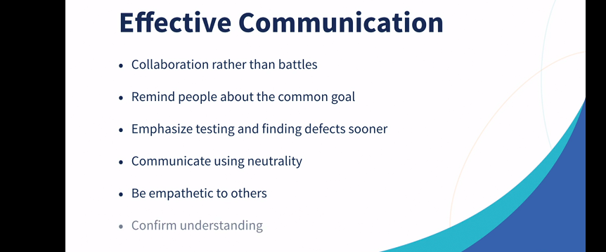
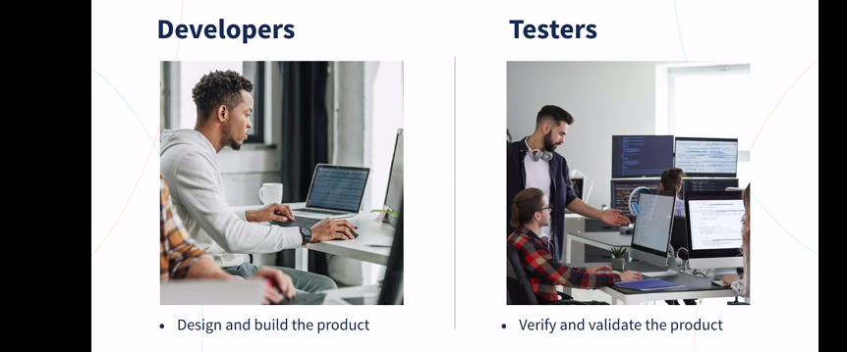
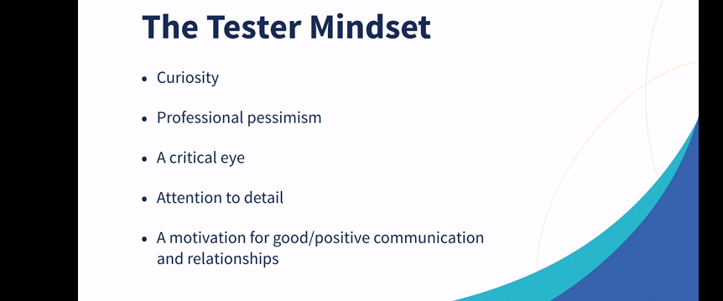
.

SDLC -

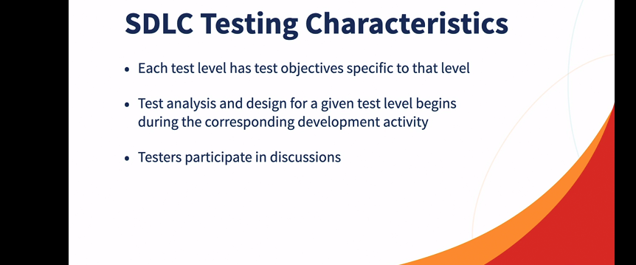
.
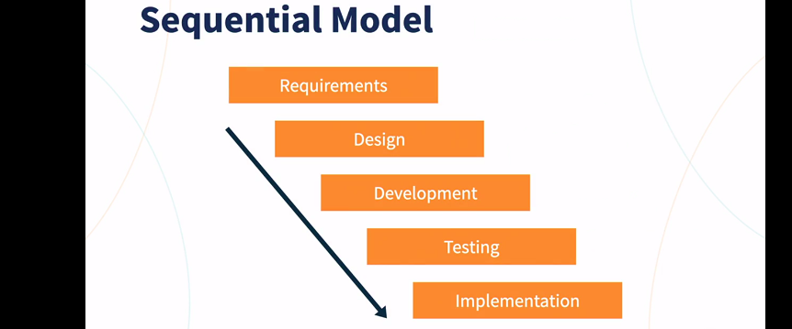
.
linear sequential flow – next activity starts only when previous activity is complete
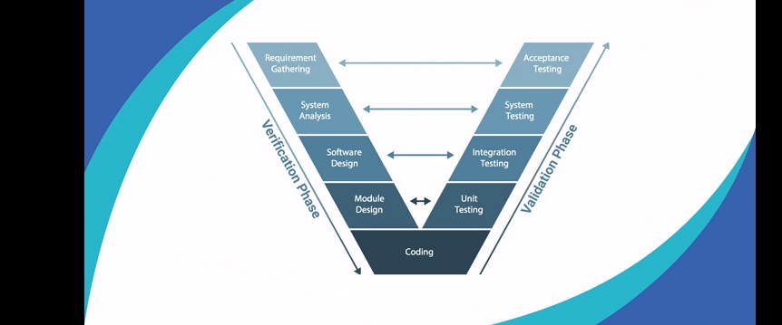
.

Iterative or incremental models - Software development grow incrementally

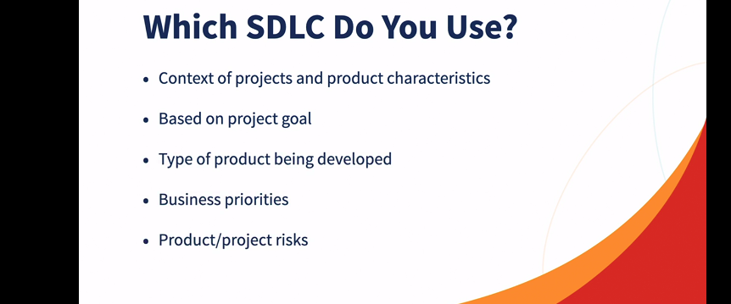
.

Test Levels -

Component – Focuses on component that are separately testable – It’s objectives are - reduces risk, verifying component behavior , build confidence in the components quality, find defects in the component and prevent defect from escaping to higher test levels

Integration – Focuses on integration between components of system – it’s objectives are – reducing risk , verifying interface behavior , build confidence, finding defects in the integration and prevent defect from escaping to higher test levels

System – Focuses on behavior and capabilities of whole system or product -it’s objectives are – reducing risk , verifying functional and non-functional behavior , build confidence in the quality of whole system, finding defects iand prevent defect from escaping to higher test levels

Acceptance

